How to Identify Quality Air Jordan Replicas: The Ultimate Guide for Collectors
In the sprawling universe of sneaker culture, the line between authorized retail pairs and high-end replicas is becoming increasingly blurred. For years, the term "replica" was synonymous with poorly constructed, obvious fakes that could be spotted from a mile away. However, the manufacturing standards in the unauthorized market have skyrocketed, giving rise to what enthusiasts call 1:1 quality Air Jordan replicas.
Whether you are a budget-conscious fashion enthusiast looking to wear your grails without fear of creasing a $1,000 asset, or a collector aiming to protect yourself from buying a fake sold as authentic, understanding the anatomy of a high-quality sneaker is non-negotiable. This comprehensive guide will take you deep into the world of sneaker manufacturing, helping you distinguish between budget batches and top-tier craftsmanship, with a special focus on the ever-popular Jordan 4.

The Evolution of the Replica Market
To understand how to identify quality, one must first understand the hierarchy of the market. Gone are the days of "AAA" grades that looked like plastic. Today, the market is dominated by specific factories (often referred to as "batches" like LJR, GX, or PK) that specialize in reverse-engineering Nike’s most iconic silhouettes.
The gold standard in this space is the 1:1 quality Air Jordan replicas. This term implies that the shoe is a material-for-material, stitch-for-stitch match to the retail counterpart. Achieving this level of accuracy requires access to the original digital blueprints or sacrificing a genuine pair to deconstruct and analyze every layer, from the density of the sole to the thread count on the tongue.
When searching for the Best Jordan 4 Replica 2026, you aren't just looking for a shoe that "looks right." You are looking for specific indicators of manufacturing provenance: correct nubuck movement, accurate color matching under UV light, and proper structural integrity that mimics the comfort of the original Air unit.

Anatomy of a Legend: How to Spot Top-Tier Quality
Identifying a high-quality replica involves a multi-sensory inspection. Here is what experts look for, specifically when analyzing Air Jordans.

1. Material Quality and Texture
The most common giveaway of a low-tier replica is the material. On models like the Air Jordan 4 or Air Jordan 1 High, the leather or nubuck should feel premium.
- Nubuck/Suede: On a high-quality pair, the material should be "alive." When you brush your finger across it, the color should shift slightly (a phenomenon known as "movement"). Budget fakes often look flat and feel like felt.
- Tumbled Leather: Authentic Jordans often use tumbled leather that has a distinct, irregular texture. Lower quality replicas often over-tumble the leather (making it look like an elephant’s skin) or use a synthetic press that looks too uniform.

2. The Smell Test
It sounds strange to the uninitiated, but the "smell test" is a veteran move. Authentic Nike shoes have a distinct smell of glue and factory chemicals, but it is not overpowering. Low-quality fakes often smell like strong gasoline or cheap rubber due to the use of toxic, lower-grade adhesives. 1:1 quality Air Jordan replicas typically use the same adhesive suppliers as the authorized factories, resulting in a scent that is nearly indistinguishable from retail.

3. Stitching Consistency
Nike’s quality control has been criticized in recent years, but their stitching generally follows a strict pattern. On a replica, look for:
- Double Stitching: Ensure the spacing is even.
- Corner Stitch (Jordan 1s): The stitching near the swoosh should not touch the swoosh itself (the "corner stitch flaw" was a common tell in older fakes).
- Heel Tabs: On Jordan 4s, the stitching under the heel tab should be clean and low-profile.

The Jordan 4: A Case Study in Replication
The Air Jordan 4 is arguably the most complex silhouette to replicate correctly due to its mix of materials, plastic wings, and netting. As we approach the new year, the search for the Best Jordan 4 Replica 2026 is heating up, with factories perfecting the "Reimagined" series and classic colorways.

The Cage Flaw
For years, the "cage flaw" was the easiest way to spot a fake Jordan 4. On the side profile of the shoe, the plastic netting should run parallel to the lace wing. On bad fakes, this netting is often perpendicular or straight. High-tier batches have corrected this, but it remains a primary checkpoint.

The Heel Tab "Flick"
A quality Jordan 4 heel tab should be snappy. When you pull it down and release it, it should immediately flick back into place with force. If the plastic feels sluggish, overly soft, or stays bent, it is a sign of cheap material usage.

The Tongue Height and Shape
The tongue on a Jordan 4 is notorious. It should be tall, have a squared-off top (not too rounded), and feature thick padding. The "Jumpman" patch must be centered perfectly. Many budget versions have "skinny tongues" that lack the plush foam filling found in the Best Jordan 4 Replica 2026.

Spotlight: Top Picks from 404Goat
To illustrate what top-tier craftsmanship looks like, we have scanned the catalog at 404goat.com to highlight three products that exemplify the 1:1 quality Air Jordan replicas standard. These specific pairs are known for their material accuracy and attention to detail.
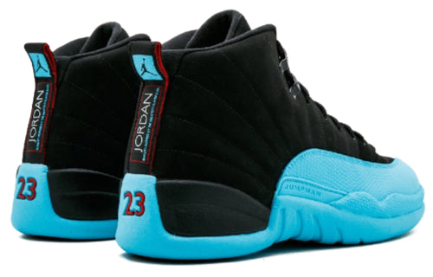

1. Air Jordan 12 Retro Gamma Blue Reps
Relive the hype of the 2013 holiday release with this impeccable Air Jordan 12 Retro Gamma Blue replica. Expertly crafted to strict 1:1 standards, this pair features a premium, buttery-soft black nubuck upper that transitions seamlessly into the iconic pebbled leather mudguard dipped in electric Gamma Blue. We haven’t missed a single detail—expect the correct Gym Red Jumpman branding on the tongue and heel, alongside a functional carbon fiber shank plate for genuine stability. Whether you are hitting the court or the streets, these reps deliver the authentic heavy-duty build and Zoom Air comfort of the original masterpiece.
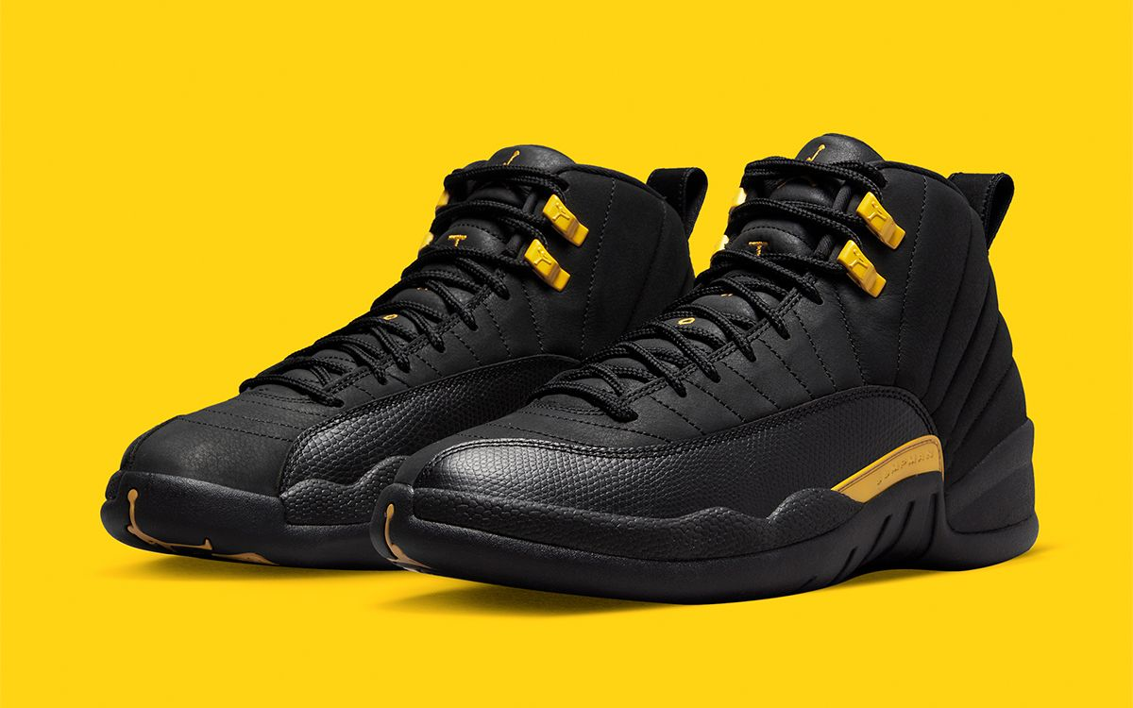

2. Air Jordan 12 Retro Black Taxi Reps
Step into stealth luxury with our Air Jordan 12 Retro Black Taxi replicas. This stunning pair flips the script on the iconic original, delivering a sophisticated all-black aesthetic highlighted by striking Metallic Gold hardware. We have meticulously recreated the premium experience, featuring a buttery tumbled leather upper paired with the signature reptile-textured mudguards that define the classic AJ12 silhouette. The gold accents on the eyelets and midfoot branding add a regal touch, identical to the 2022 retail release. Engineered for 1:1 accuracy and all-day comfort, these kicks offer the perfect blend of heritage style and high-end craftsmanship for your collection.
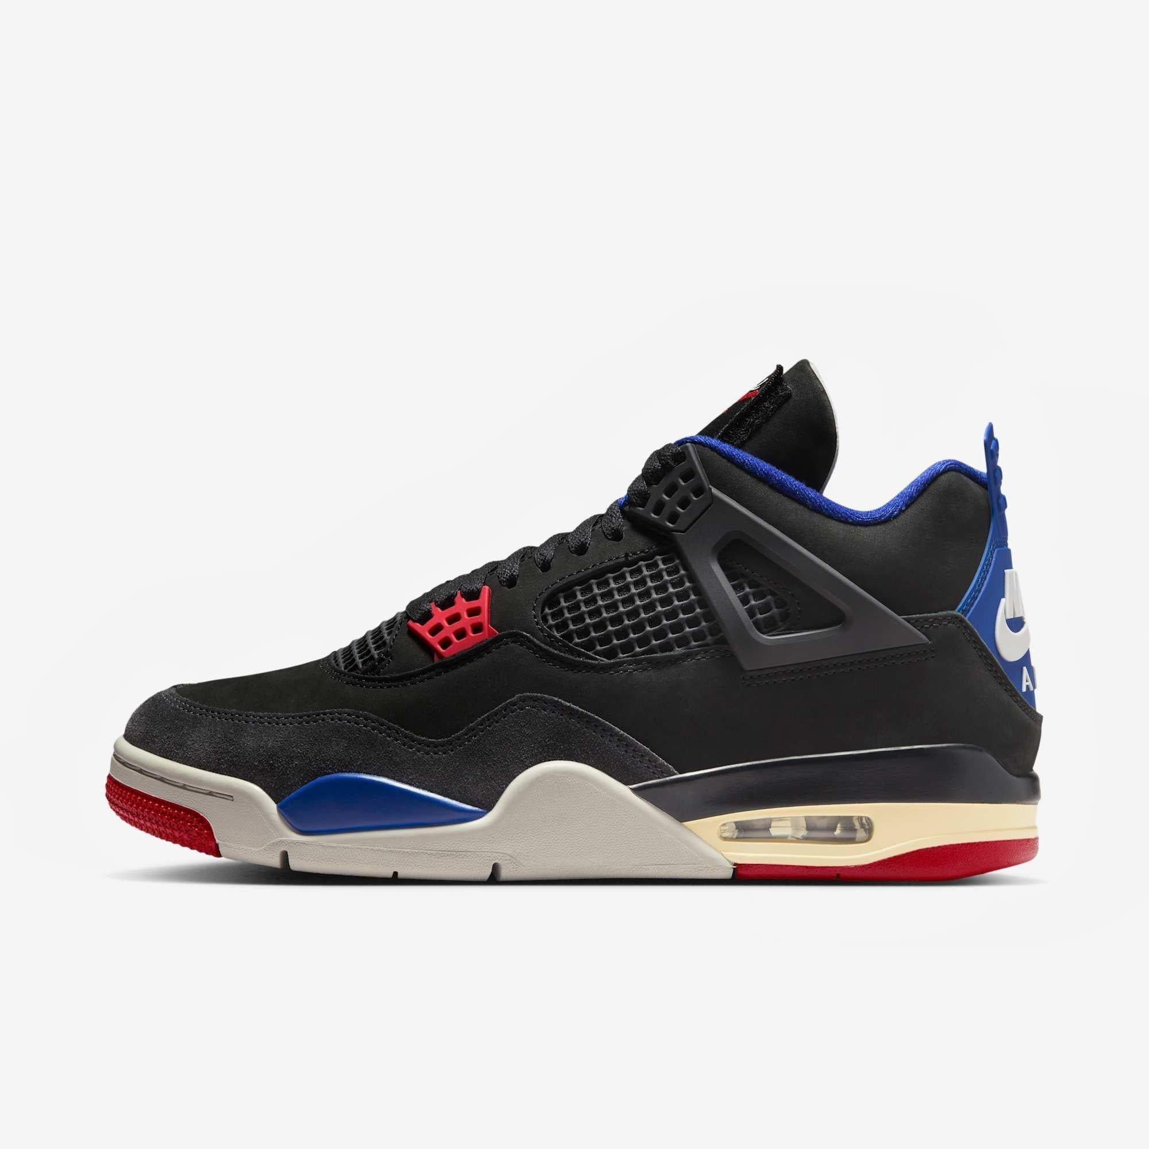

3. Jordan 4 Retro ‘Rare Air – White Lettering’ 2025 Replica
Step into the future of sneaker culture with the Jordan 4 Retro ‘Rare Air – White Lettering’ 2025 Replica. This high-tier edition meticulously recreates the 2025 release, featuring a premium black nubuck upper contrasted by sleek grey suede overlays. The hallmark of this model is the interchangeable Velcro tongue patches that peel back to reveal the exclusive "Rare Air" white lettering. Accented with vibrant Fire Red eyelets and Deep Royal Blue linings, these kicks capture the "accidental legend" aesthetic perfectly. Finished with iconic Nike Air heel branding, it’s a must-have for those seeking the ultimate 2025 grail.

Manufacturing Batches: The Secret to Consistency
If you want the Best Jordan 4 Replica 2026, you need to know which "batch" you are buying. Sellers like 404Goat often source from top-tier batch lines.
- GX Batch (Green X): Currently widely regarded as the king of Jordan 4s. They have invested heavily in molds that mimic the retail shape perfectly. Their Black Cats and Breds are nearly flawless.
- LJR Batch: Famous for Jordan 1s, but also decent for 4s. LJR is known for high-quality materials but sometimes misses slightly on the bulky shape of the 4.
- PK 4.0: A newer contender that has nailed the "shape" of the toe box, making it incredibly sleek and close to the 2025/2026 remasters.
Knowing these names helps you verify that you are getting 1:1 quality Air Jordan replicas rather than a generic mass-market version.

Red Flags When Buying Online
Even with the best knowledge, buying online carries risks. Here is how to protect yourself:
- "Bait and Switch": Some sellers show photos of a real shoe or a high-tier batch but ship a budget pair. Always look for sellers with community trust or those who provide "QC" (Quality Control) photos before shipping.
- Price is Too Good to Be True: A top-tier replica costs money to make. The materials alone are expensive. If you see a "perfect" Jordan 4 for $40, it is a budget batch. True 1:1 quality Air Jordan replicas generally range from $100 to $160 due to the cost of premium leather and labor.
- Stock Photos vs. In-Hand: trusted sites will often have consistent backgrounds in their product photography.

The Future of Replicas: 2026 and Beyond
As we look toward the future, the technology used to create sneakers is becoming more accessible. 3D printing and automated knitting are allowing replica factories to iterate faster than ever. The Best Jordan 4 Replica 2026 will likely feature even more improvements in internal comfort technologies, such as correctly pressurized Air units and polyurethane insoles that don't crumble over time.
We are also seeing a trend toward "fantasy" pieces—colorways that were never released by Nike but are produced with high-quality materials by these factories. However, for the purist, accuracy remains the goal.

Conclusion
Identifying quality in the replica market is a skill honed over time. It requires an eye for detail, an understanding of materials, and knowledge of the manufacturing landscape. By focusing on the movement of the nubuck, the snap of the heel tab, and the precision of the stitching, you can ensure that you are getting your money's worth.
Whether you are eyeing the Black Cat or the Military Black from 404goat.com, remember that knowledge is your best defense. The gap between retail and replica has narrowed significantly, and with the right information, you can enjoy the style and history of Air Jordans without the aftermarket markup. Keep searching for those 1:1 quality Air Jordan replicas, and you will find that the Best Jordan 4 Replica 2026 is likely already within your reach.

